Here’s your single, clean, consolidated study guide document - structured, complete, and readable. I’ve merged everything into one cohesive flow, preserved code, concepts, explanations, and added light structure so you can actually study from it.

🧠 Deep Learning Master Study Guide (Complete)
(Compiled from your full material)

1. Core Tools & Ecosystem
TensorFlow
- Open-source platform for building and training neural networks
- Used for:
  - Research
  - Production systems
- Runs on:
  - CPUs, GPUs, TPUs
📎 https://www.tensorflow.org/tutorials

Keras (tf.keras)
- High-level interface for TensorFlow
- Lets you build models quickly with minimal code
Example:
model = tf.keras.Sequential([...])
👉 You describe the model → it handles the details

Google Colab
- Cloud-based coding environment
- No setup required
- Free access to GPU/TPU
📎 https://colab.research.google.com/notebooks/intro.ipynb

2. Working with Data
Upload from local
from google.colab import files
uploaded = files.upload()
Load dataset
import pandas as pd
data = pd.read_csv('filename.csv')
Use Google Drive
from google.colab import drive
drive.mount('/content/drive')
data = pd.read_csv('/content/drive/MyDrive/.../file.csv')

3. Math Foundations
Functions
- Relationship between input and output
- Example:
f(x) = x²

Derivatives (core idea)
- Measures how something changes
- Example:
f(x) = x² → derivative = 2x
👉 Used to:
- Adjust model parameters
- Reduce error

Why this matters
Derivatives power:
- Backpropagation
- Gradient descent

4. Neural Networks (ANN)
Structure
- Input layer → receives data
- Hidden layers → learn patterns
- Output layer → produces result

Key Terms (plain meaning)
- Neuron: small calculator
- Weight: importance of input
- Bias: extra adjustment
- Training set: data with answers

5. Forward vs Backward Propagation
Forward propagation
- Input → prediction
Steps:
- Multiply inputs by weights
- Add bias
- Apply activation function

Activation functions
Function | Behavior
Sigmoid | outputs 0–1
Tanh | outputs -1 to 1
ReLU | 0 if negative, x if positive
Softmax | converts to probabilities

Backpropagation
- Updates weights using error
- Uses derivatives

6. Loss Functions
Purpose
Measures how wrong the model is
Types
- Regression → Mean Squared Error
- Classification → Cross-Entropy

7. Gradient Descent
Formula
w = w - η * (dC/dw)
Terms explained
- w (weight) → adjustable parameter
- C (cost) → error
- dC/dw → slope (direction to move)
- η (learning rate) → step size

Intuition
👉 Like going downhill to minimize error
- Big slope → big move
- Small slope → small move
- Stop when slope ≈ 0

8. Deep Learning Workflow
- Forward pass
- Compute loss
- Backpropagation
- Update weights
- Repeat

9. Full Neural Network Code
Model definition
model = tf.keras.Sequential([
tf.keras.layers.Flatten(input_shape = (28, 28)),
tf.keras.layers.Dense(64, activation = 'relu'),
tf.keras.layers.Dense(10, activation = 'softmax')
])

Compile
model.compile(
optimizer='adam',
loss='categorical_crossentropy',
metrics=['accuracy']
)

Train
fit_history = model.fit(
X_train, y_train,
validation_split=0.1,
verbose=1,
epochs=10,
batch_size=64
)

Evaluate
model.evaluate(X_test, y_test, verbose=1)

One-hot encoding
y_train = tf.keras.utils.to_categorical(trainY, num_classes=10)

10. What model.fit() Means (Plain English)
👉 “Train the model using your data”
- X_train → inputs
- y_train → correct answers
- validation_split → hold-out check data
- epochs → number of training passes
- batch_size → how many examples at once
- verbose → show progress

11. GPU vs TPU
CPU vs GPU vs TPU
Type | Strength
CPU | general tasks
GPU | many calculations at once
TPU | deep learning optimized

GPU
- Runs many operations in parallel
- Standard for deep learning
Example: T4 GPU in Colab

TPU
- Designed specifically for neural networks
- Faster for certain large models

Key takeaway
- GPU → easiest + widely used
- TPU → powerful but more specialized

12. Neural Network Layers (Intuition)
Flow
Input → Hidden → Output

What happens inside a neuron
- Multiply inputs by weights
- Add values
- Apply function

Mental model
- Layer 1 → simple patterns
- Layer 2 → shapes
- Layer 3 → objects

13. Advanced Architectures
Fully Connected
- Everything connected to everything
- Good for simple data

CNN (images)
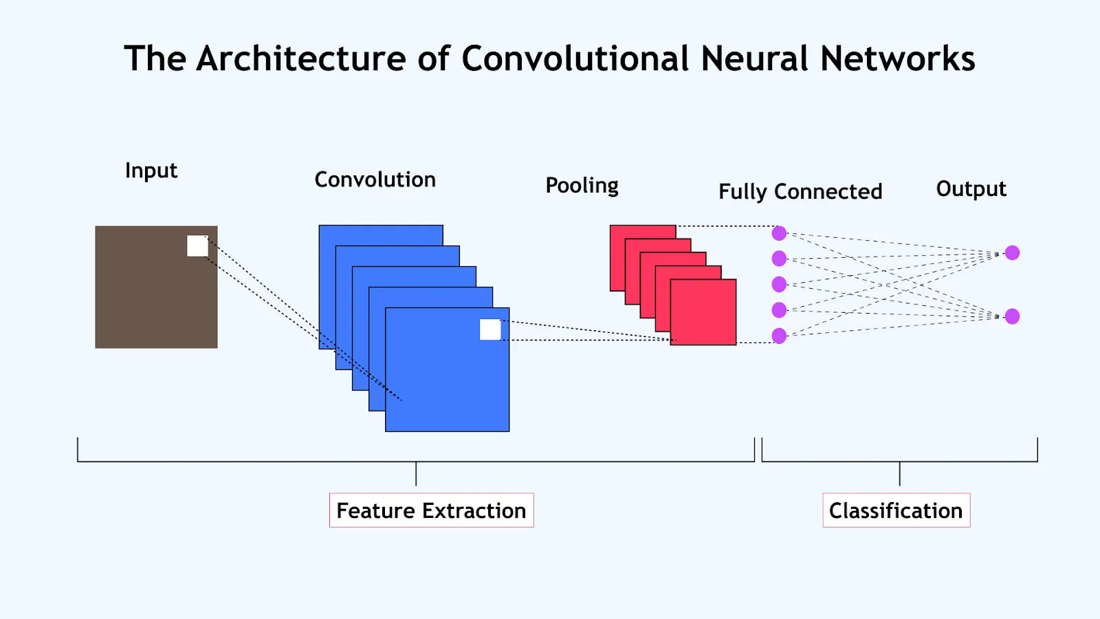
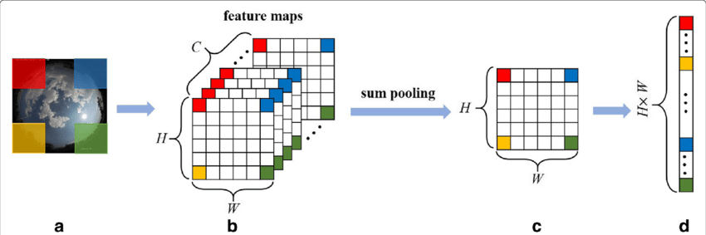
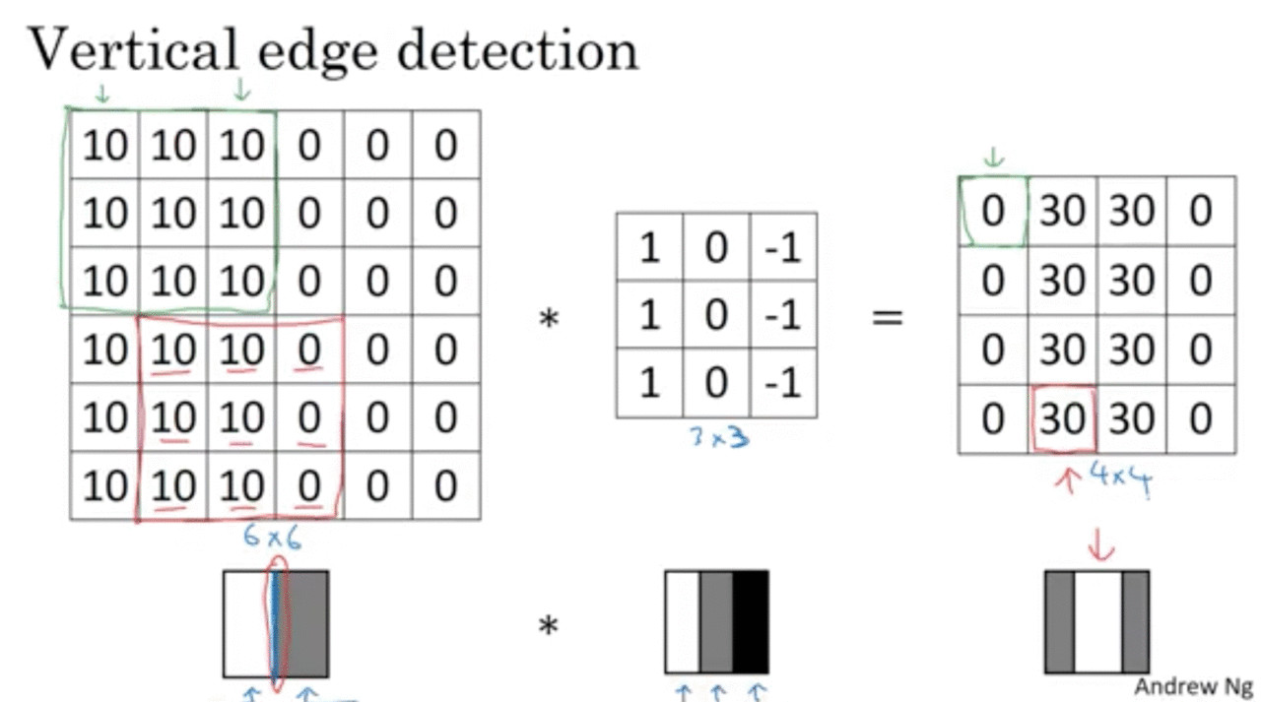
- Detects patterns in images
- Uses filters
- Builds:
  - edges → shapes → objects

RNN (sequences)
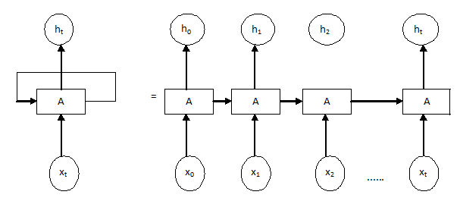

- Processes data step-by-step
- Remembers previous inputs

LSTM (long memory)
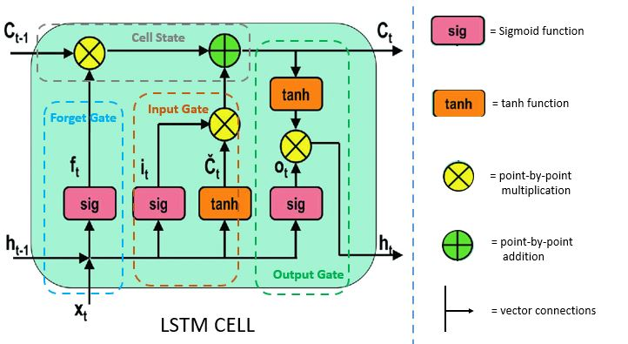
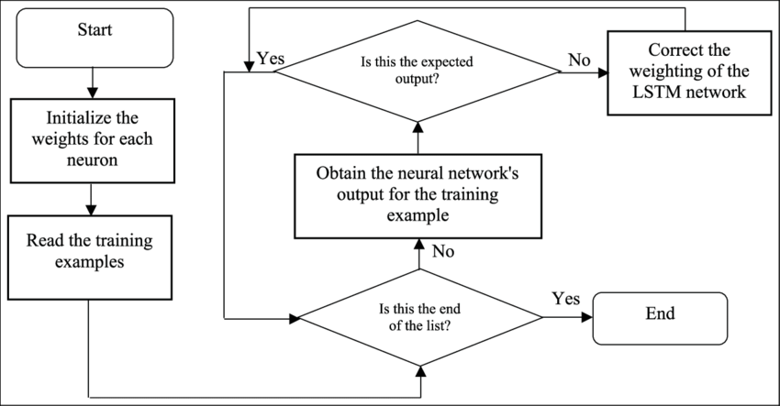
- Decides:
  - what to keep
  - what to forget

GAN (generation)

- Two networks:
  - generator (creates)
  - discriminator (judges)

U-Net (segmentation)
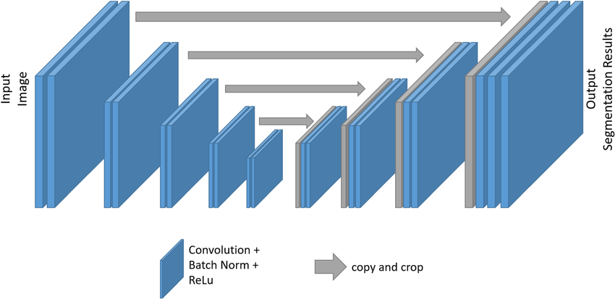

- Pixel-level predictions
- Used in medical imaging

Transformer (modern AI)

- Uses attention
- Looks at relationships between all inputs

14. Transformer vs GPT vs T5
ChatGPT (GPT)
- Decoder-only
- Generates text step-by-step

BERT
- Encoder-only
- Understands text

T5
- Encoder + decoder
- Reads → then writes
- T5 (Unified Model)
- 🔹 T5
- 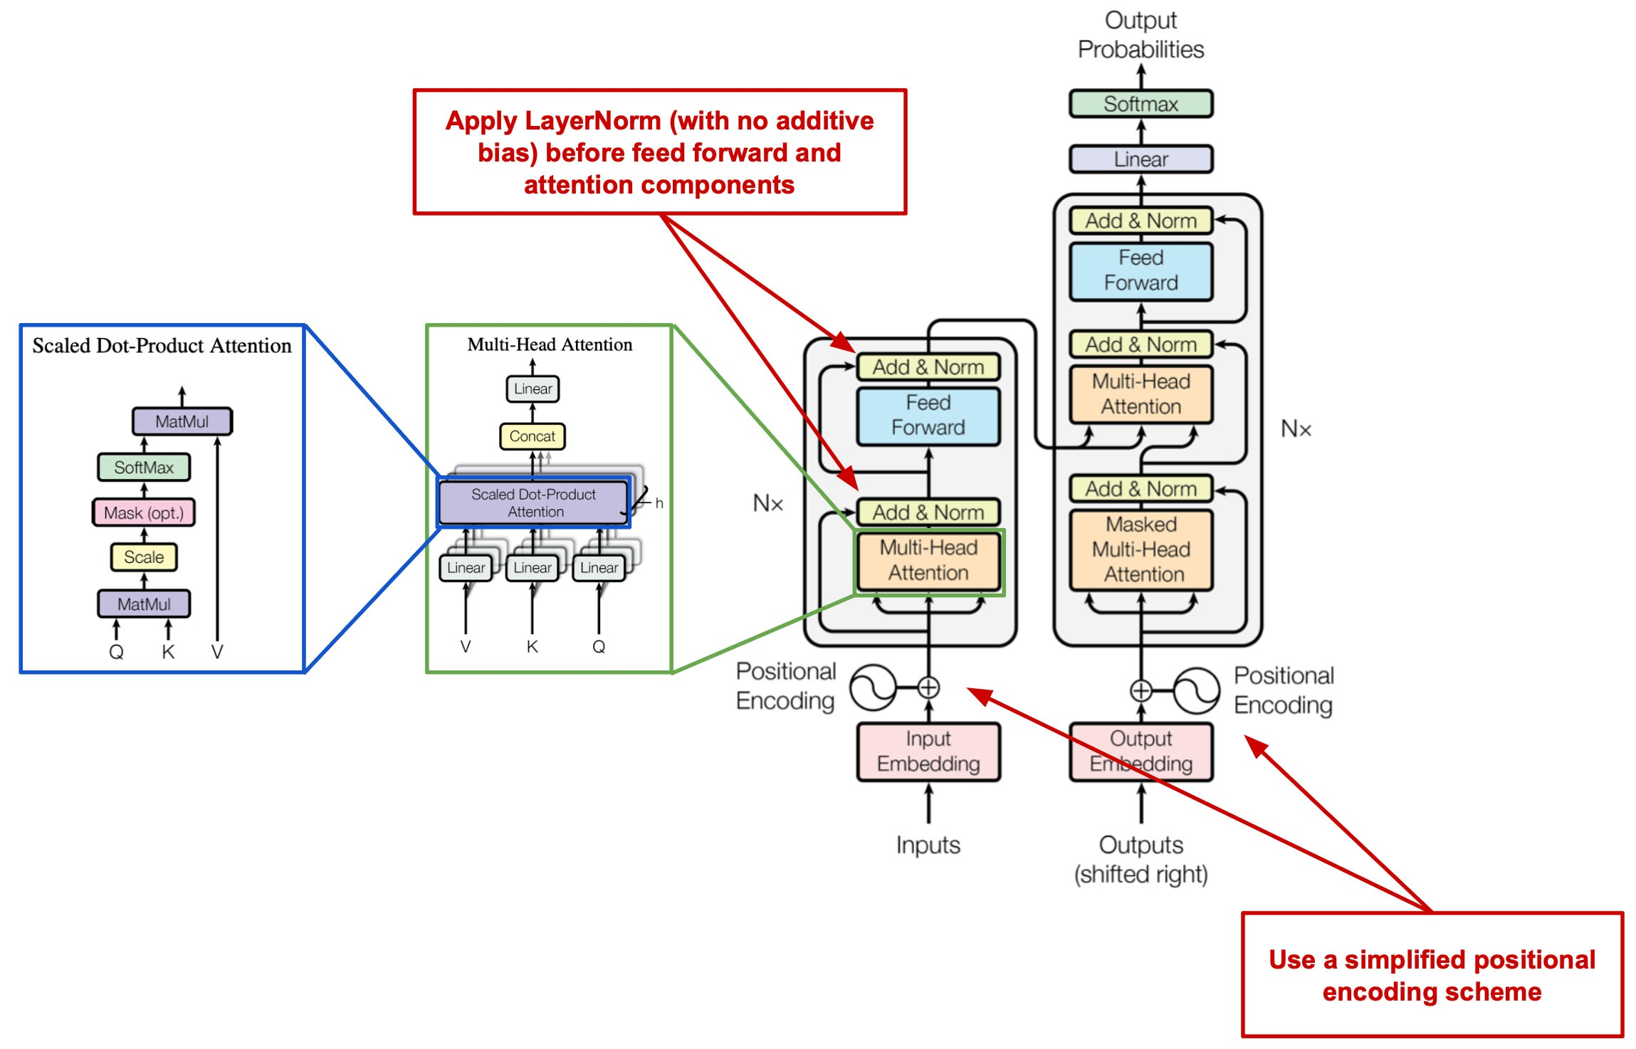
- 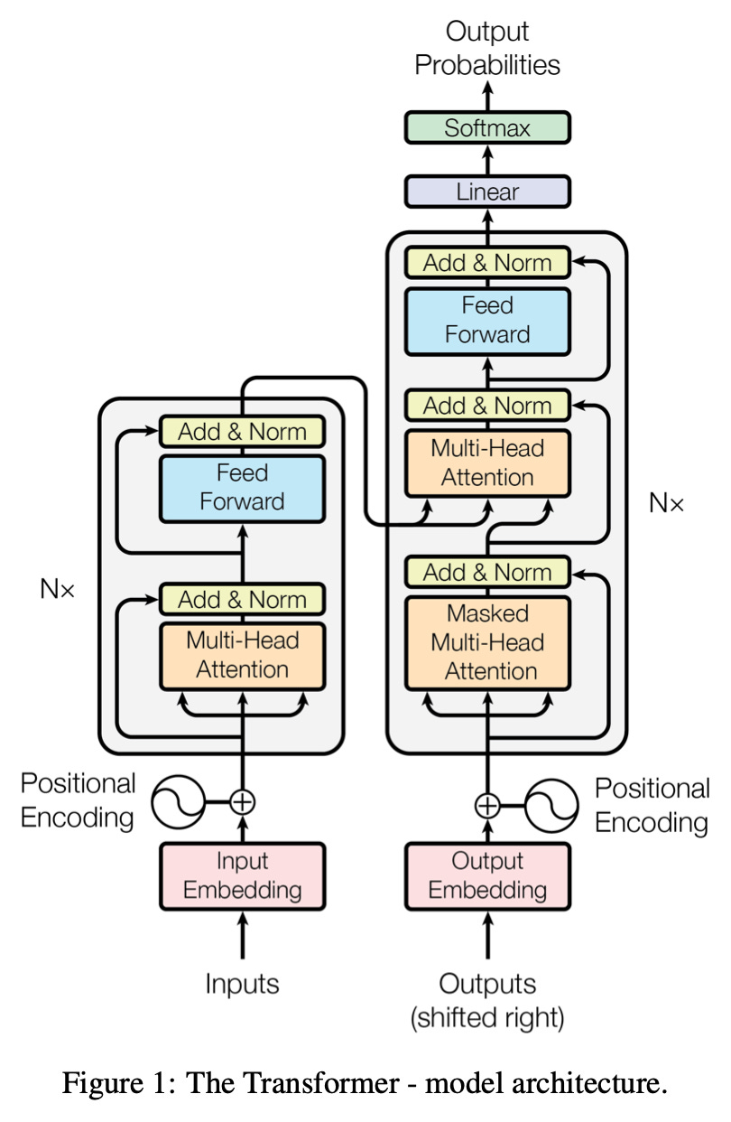
- T5 (Unified Model)
- 🔹 T5
- 
- 
- 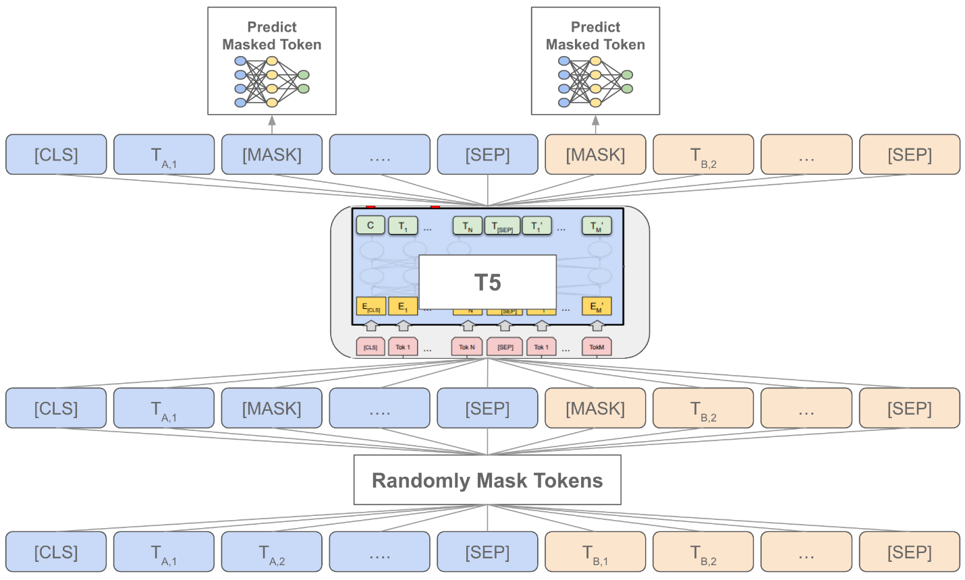
- 4

- Core idea
- 👉 Everything = text → text
- Examples:
- “translate English to German: hello”
- “summarize: [text]”
- “classify sentiment: positive/negative”
- 
- 4

- Core idea
- 👉 Everything = text → text
- Examples:
- “translate English to German: hello”
- “summarize: [text]”
- “classify sentiment: positive/negative”
- vv

Key difference
Model | Role
BERT | understanding
GPT | generation
T5 | both

15. Core Intuition (Most Important)
👉 Neural networks = function approximators
y = f(x; weights)
Training = minimize error

What learning actually is
- Make prediction
- Measure error
- Adjust weights
- Repeat

16. Big Picture Pipeline
- Input data
- Forward pass
- Compute loss
- Backpropagation
- Gradient descent
- Repeat

17. External Resource
📎 https://missinglink.ai/guides/neural-network-concepts/complete-guide-artificial-neural-networks/

18. How to Study This
Pass 1 - Understanding
- Forward vs backward
- Loss + gradient descent
Pass 2 - Mechanics
- Code
- Derivatives
Pass 3 - Mastery
- Explain backprop
- Explain gradients

✅ Final One-Line Summary
👉 Deep learning = repeatedly adjusting numbers inside a network so predictions get closer to the correct answer.

If you want next, I can:
- Turn this into flashcards
- Build a 1-page cheat sheet
- Or make a step-by-step “one example through a network” walkthrough (very high yield)

